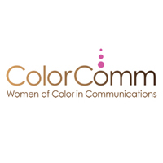
JOB DESCRIPTION
COMMUNICATIONS MANAGER

ABOUT COLORCOMM, INC:
ColorComm, Inc. is the nation's leading women's platform addressing diversity and inclusion from across the communications, marketing, media, and advertising industries. ColorComm, Inc. houses ColorComm Network, ColorComm’s 6th Annual Conference, ColorComm’s Next Generation Conference, and ColorComm Media Group.

COMMUNICATIONS MANAGER
- The Communications Manager for ColorComm, Inc. will be responsible for working across all platforms to develop a communications strategy to up level communications nationally and internationally.
- This role will be responsible for developing new content for organizational materials and communications on a daily basis.
- This role will be responsible for maintaining and cultivating relationships with the ColorComm community, third party advocates, and media personnel.
- This role will be responsible in developing new partners for ColorComm, Inc.
- This role will be responsible for overseeing social media strategy.
- This role is a fast past position that requires strong attention to detail and the ability to be proactive and thoughtful in everyday assignments.

Payment
- Annual salary commensurate with experience

EXPERIENCE
- 4 – 6 years relevant experience in corporate, non-profit, or agency with experience in a traditional communications role
- Experience presenting and articulating communications strategy, including campaign goals objectives, and how success is measured
- Superior written and verbal communication skills
- Collaborative and inclusive work style

OFFICE HOURS
M – F; 9 am -6pm; one hour lunch break

