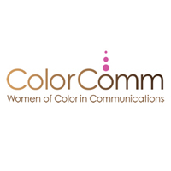
JOB DESCRIPTION
SOCIAL MEDIA MANAGER - COLORCOMM, INC.

ABOUT COLORCOMM, INC:
ColorComm, Inc. is the nation's leading women's platform addressing diversity and inclusion from across the communications, marketing, media, and advertising industries. ColorComm, Inc. houses ColorComm Network, ColorComm’s 6th Annual Conference, ColorComm’s Next Generation Conference, and ColorComm Media Group.

SOCIAL MEDIA MANAGER
- Stay current on the latest social platforms, functionality and integrations to work across all of ColorComm’s social platforms
- Develop solutions for creating and activating the highest quality social content to drive business results
- Demonstrate strategic thinking, generate enthusiasm for digital work and position the company as a creative thought leader
- This role is a fast past position that requires strong attention to detail and the ability to be proactive and thoughtful in everyday assignments.

Payment
- Annual salary commensurate with experience

EXPERIENCE
- 4 – 6 years relevant experience in corporate, non-profit, or agency with experience in a digital/social media role.
- Experience presenting and articulating social strategy, including campaign goals ,objectives, and how success is measured
- Superior written and verbal communication skills
- Collaborative and inclusive work style

OFFICE HOURS
M – F; 9 am -6pm; one hour lunch break

